**A11 Assignment- Concept Sketches**

**Homeless Shelter**

**Group L: Portifize**

**Concept Descriptions**

1. *The Spring Design*

Description of system:

The Spring Design is a rectangular-shaped tent in its fully extended form. As a tent, it provides shelter from the elements, including the cold, rain, and snow. This design features a foldable sleeping mat that can be spread on the floor to provide a comfortable and insulative layer between the user and the cold ground. The dimensions of the tent are large enough to allow the user to sleep comfortably without feeling confined and to sit up without the ceiling getting in the way. To collapse the tent, all one must do is squeeze the two ends together and secure it into place by fastening the sinch ties. The use of a square spring on the inner frame of the tent makes the process of collapsing the tent into its backpack form easy and simple. As a backpack, this design is comfortable for the user as it has backpack straps that allow the user to carry. It also features plenty of pockets for storage space.

Gains produced by this design:

Because of how simply the tent converts into a backpack, and because the overall design serves two purposes imperative to our users’ needs, this design will be beneficial in terms of its convenience, simplicity, and portability. This design will also capitalize in comfort as its built-in sleeping mat provides protection from the cold and uneven ground—a feature that many tents currently on the market do not offer.

*Sketch:*

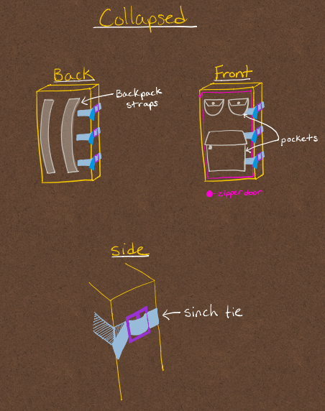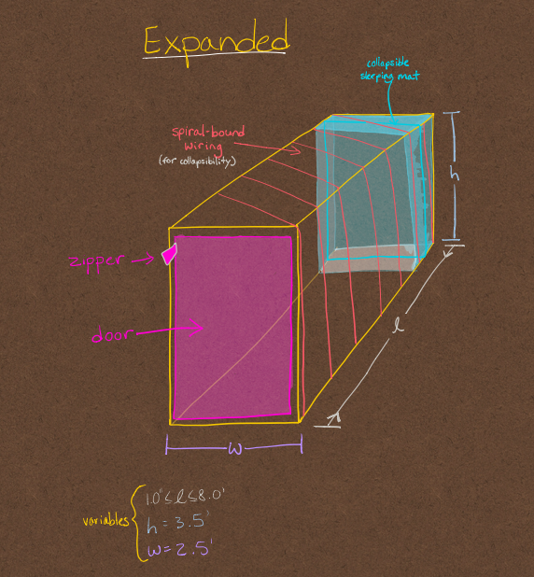

1. *The Accordion Design*

The accordion design's main feature is the folding mechanism used to collapse the tent. If the tent were rectangular, it would not need a metal frame but would collapse by way of the folds in the material of the tent itself. This would reduce production cost and make the tent simpler to use and easier to transport without the added weight of a frame. The accordion design can also be shaped as a dome that folds in half. The dome shape would require a metal frame but in the end, would provide the user with more head room and is a new take on the traditional tent design. This design would be integrated with a backpack to allow ampl portability and has enough room to fit folded padded bedding to sleep on for more user comfort.

Gains Produced by this Design:

Both designs express multiple potential values, for example when examining the dome shaped tent we can see that when opening the tent it will prove to be fairly easy to do so. Although, one drawback from this design is the fact that since it's a dome shape not only would it be difficult to fold back into the backpack but it would also hinder the ability to maximize the internal space within the shelter itself. As result the team has decided to ultimately focus on the rectangular design (Accordion Design), because this design would allow us to maximize the internal space in the shelter and give the feeling of being less cramped for the user ultimately making this gain. This design also houses another gain of being able to quickly fold it and put it away with ease making it extremely convenient for the user.

*Sketch:*

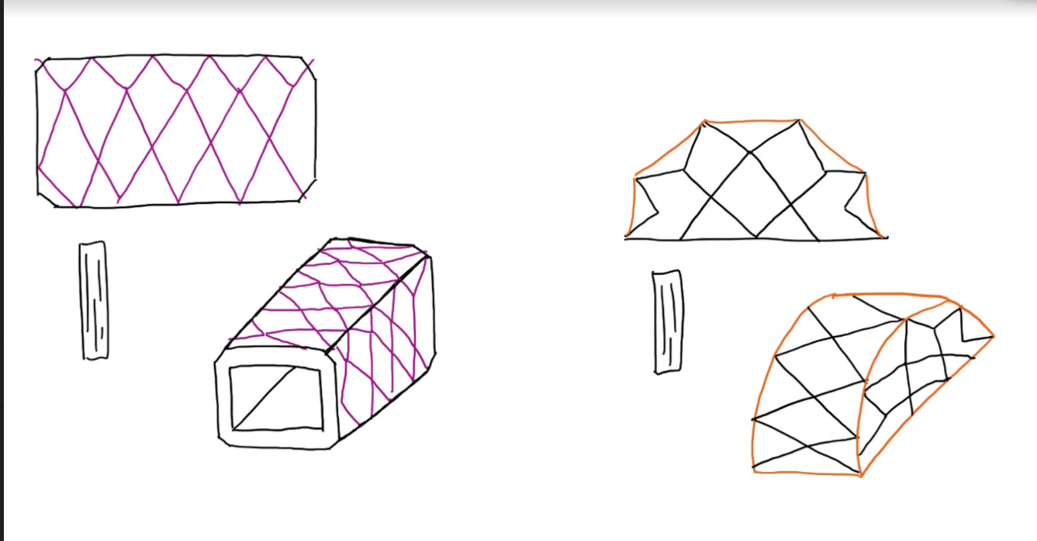

**Pugh Scoring Matrix**

The pugh scoring matrix is a method to quantify how our conceptual designs compare with an already existing alternative and how well each product addresses our user needs. The pugh scoring matrix uses the weightings determined in our problem definition and makes deciding between ideas quicker and ensures we discuss all aspects and features of each idea. Using our rankings and weightings, each idea is given a total score; the design with the highest score does the best job of meeting our user needs and will be our main design concept as we continue through the design process.

|  |  | **Traditional 4-person Dome Tent** | | **The Spring Design** | | **The Accordion Design** | |
| --- | --- | --- | --- | --- | --- | --- | --- |
| **Needs** | Wgt | Rating | Weighted score | Rating | Weighted score | Rating | Weighted score |
| Simple | 3 | 2 | 6 | 5 | 15 | 5 | 15 |
| Inexpensive | 1 | 3 | 3 | 3 | 3 | 3 | 3 |
| Portable | 4 | 4 | 16 | 5 | 20 | 4 | 16 |
| Long-term reusability | 6 | 4 | 24 | 3 | 18 | 3 | 18 |
| Comfort | 2 | 2 | 4 | 4 | 8 | 2 | 4 |
| Convenient | 5 | 2 | 10 | 5 | 25 | 3 | 15 |
| Visually appealing | 0 | 5 | 0 | 5 | 0 | 5 | 0 |
| Total score: | |  | 63 |  | 89 |  | 71 |
| Rank: | |  | 3 |  | 1 |  | 2 |

**Appendix:**

| **AO11 Assignment** | | | |
| --- | --- | --- | --- |
| **Project Manager for Assignment** | | | |
| Leah Norton | | | |
| **Deputy Manager for Assignment** | | | |
| Ashwin Rajkumar | | | |
| **Drafted Assignment** | **Reviewed Assignment** | **Revised Assignment** | **Proofread Assignmnet** |
| Leah Norton | Ashwin Rajkumar | Avi Popat | Ella Wulforst |
| **Created Figures** | | **Created Tables** | |
| Leah & Ella | | Ella Wulforst | |
| **Other Contributions** | | | |
| N/A | | | |
| **Problems Overcome** | | | |
| N/A | | | |